OBJECT: CREATE A TIME TABLE AND CALNEDER IN WORD.
LAB 05
CALENDER
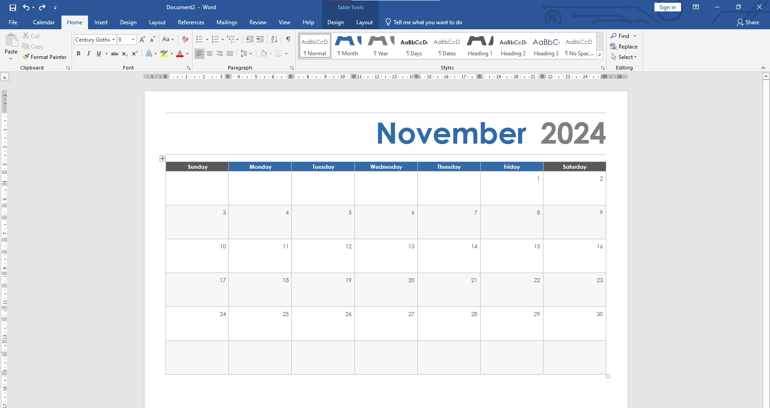
TIME TABLE
